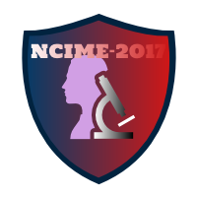

**Patron**

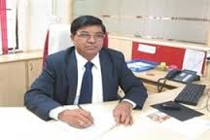

**Dr. M. S. Gaikwad**

**(Director STES Campus, Lonavala)**

**(Principal, SIT, Lonavala)**

I am delighted to announce that our Department of Mechanical Engineering has organized its 5th National Conference on “Innovations in Mechanical Engineering” during 17th – 18th March, 2017. This department is always proactively working on activities like project exhibitions, business club, workshops, seminars, expert talks by eminent personalities in the field.

I am sure that the discussion, deliberations and brain storming sessions conducted in this conference will provide exposure to researchers, academicians and persons from industries. This conference will produce an outcome which may be beneficial for the society in future.

I wish best of luck and grand success to this conference.